**MINEX SUMMARY**

**Model 30-29-200-B 5C4 Chassis, Borosilicate Glass, Low Vibration Cryo Mount,**

**Capacitor Board and Beryllium Copper Traces**

**Vacuum Very Good Running in intermittent mode around 9watts (data recorded)**

**Cryo Very Good Cooldown ColdHd 65K / LNA 70K, around 115watts (data recorded)**

**X-pole Very Good Noise (5.25 - 4.00dB out to 14GHz)**

**Y-pole Very Good Noise (6.50 - 5.50dB out to 14GHz)**

**LNA RECOMMENDED BIAS SETTINGS**

**Vm + Vd must be set exactly to values below**

**Adjust Vg as needed to get Id 25.1 to 25.3**

|  |  |  |  |
| --- | --- | --- | --- |
| **Pole** | **Minex LNA S.N.** | **Bias at Minex** | **PAM’s (HC default)** |
| **X** | **C-0015a** | **Vm -.50v / Vg .38v / Vd 1.20v / Id 25.1ma** | **15.0 / 15.0** |
| **Y** | **C-0023a** | **Vm -.50v / Vg .11v / Vd 1.20v / Id 25.1ma** |

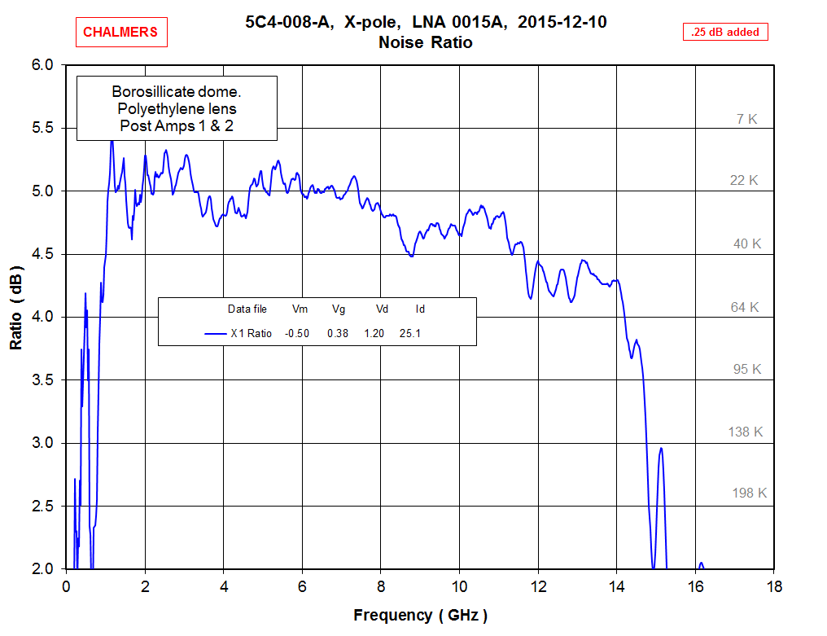

4.39” x 6.21”